|  |
| --- |
| 1. **Leqaa Ashraf** |
| 1. **Rokaya Hassan** |
| 1. **Waad Walid** |
| 1. **Fadia Hossam** |
| 1. **Mario Hatem** |
| 1. **Yousef Waleed** |

**Contents**

**Contents** 2

**Project Title: Implementing Network Security with ACLs and NAT** 3

**1.Project Overview** 4

**2. Objectives** 4

**3. Network Architecture Overview** 4

4. **Key Technologies and Protocols** 4

5. **Security Considerations** 5

**6. Implementation Details** 5

**7. Benefits of the Project** 5

**8. Target Audience** 5

9. **Use Cases** 6

**10. Conclusion** 6

**11. Future Improvements** 6

**Project Title: Implementing Network Security with ACLs and NAT**

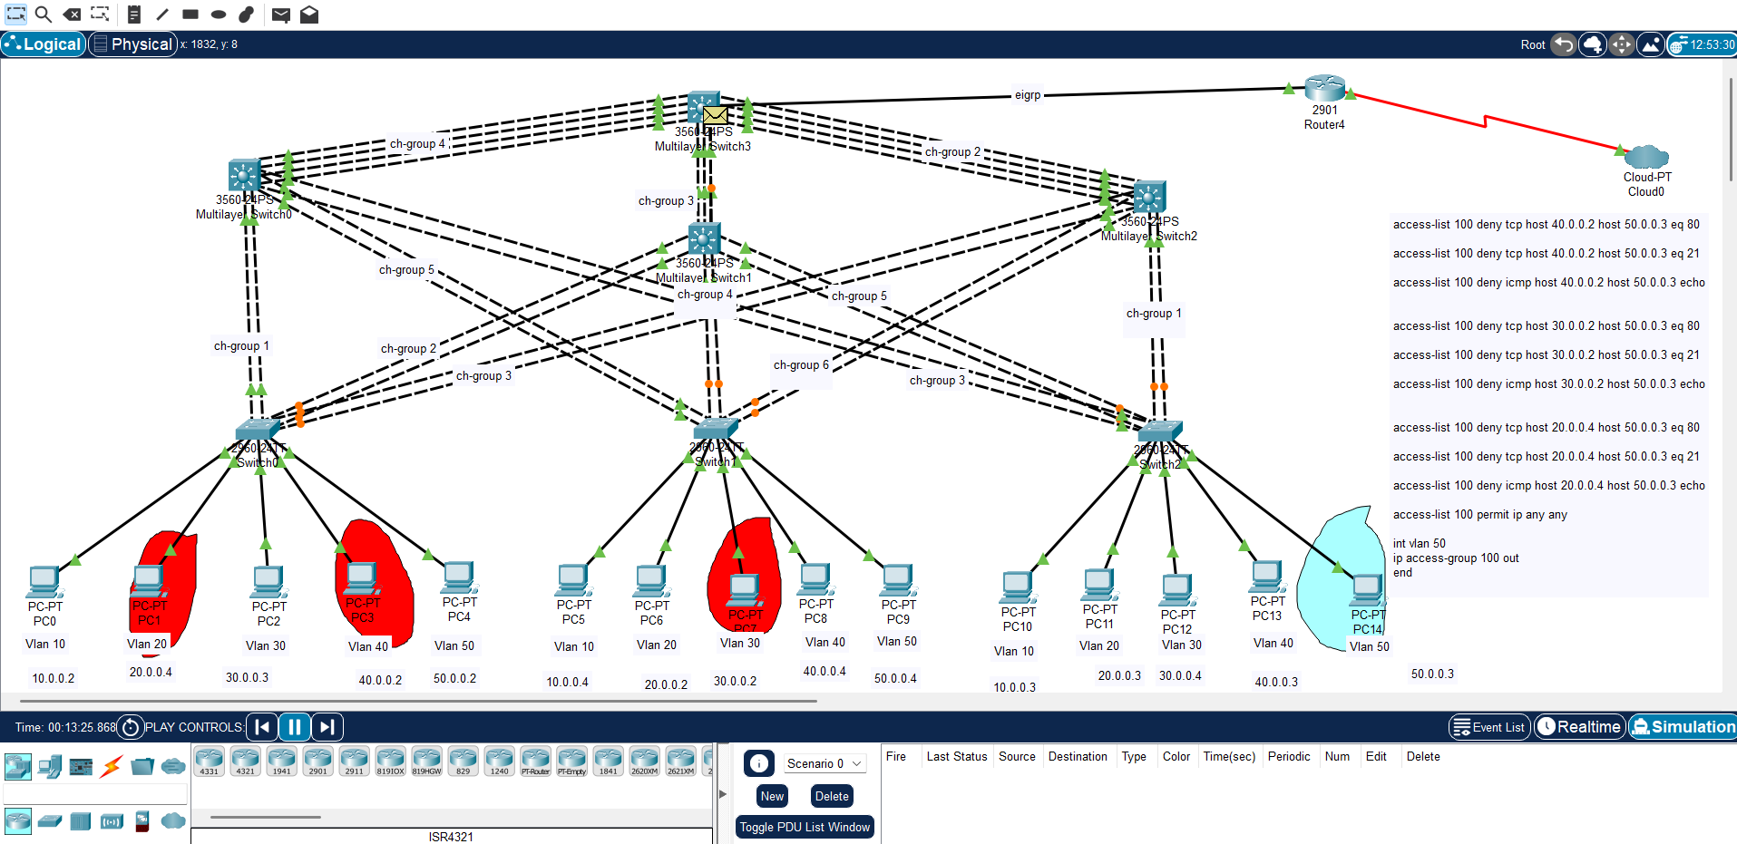

**1.Project Overview**

* The goal of this project is to design and implement a secure network using Access Control Lists (ACLs) and Network Address Translation (NAT), ensuring that both security and efficient traffic management are prioritized. ACLs play a critical role in filtering traffic and controlling access, while NAT secures the network's internal structure by translating internal IP addresses to public IP addresses for external communication.
* To enhance the network's security and performance, this project incorporates various network protocols like Spanning Tree Protocol (STP), VLAN Trucking Protocol (VTP), Port Security, and more. These protocols help to prevent unauthorized access, improve traffic management, and provide redundancy in case of network failures.

**2. Objectives**

* To implement a secure, scalable network architecture using Access Control Lists (ACLs) and Network Address Translation (NAT).
* To incorporate network security measures that ensure controlled access to resources, protection against external threats, and efficient traffic management.
* To provide a flexible infrastructure that can be easily expanded and adapted to future growth.

**3. Network Architecture Overview**

This section provides a high-level description of the network layout, including:

* **Network Topology**: Brief description of the physical and logical layout of the network, such as how devices (routers, switches, servers, and end devices) are interconnected.
* **VLAN Structure**: Details on how VLANs are structured to segregate traffic for better security and traffic management.
* **Routing and Switching**: An overview of how traffic flows within the network, detailing the routing protocol (OSPF or EIGRP) and the switching technologies in use.

4. **Key Technologies and Protocols**

This section provides a breakdown of all the key protocols used and why they are essential for the network design. Each protocol should be explained with respect to its specific role in securing and optimizing the network.

* **Spanning Tree Protocol (STP)**
* **Access Control Lists (ACLs)**
* **Network Address Translation (NAT)**
* **Port Security**
* **VLANs and VTP**
* **Dynamic Routing (OSPF/EIGRP)**

5. **Security Considerations**

* **Internal Threats**: How ACLs and VLANs can mitigate risks associated with insider threats by limiting access to critical areas of the network.
* **External Threats**: The role of NAT in protecting the internal network from unauthorized access by external users, and how ACLs filter traffic to prevent malicious packets from entering the network.
* **Port Security and BPDU Guard**: Specific considerations to prevent unauthorized devices from accessing the network and protecting the switching infrastructure from attacks.

**6. Implementation Details**

This section covers the step-by-step process of implementing the network configuration:

* **Device Configuration**: Outline the configuration of key devices such as routers and switches, with a focus on ACLs and NAT setup.
* **Protocol Configuration**: Detailed explanation of how the Spanning Tree, routing, and security protocols were configured on network devices.
* **Testing and Validation**: Describe the process used to test the network configuration, ensuring all protocols and security measures were correctly implemented and functioning.

**7. Benefits of the Project**

* **Security**: How the combination of ACLs, NAT, and other security protocols creates a robust defense against both internal and external threats.
* **Traffic Optimization**: Benefits of using dynamic routing protocols (OSPF/EIGRP) for efficient traffic flow and reducing congestion.
* **Scalability and Redundancy**: Highlighting how the network can be easily expanded and how redundancy protocols ensure minimal downtime in case of failures.

**8. Target Audience**

Detailing who will benefit from this project:

* **Network Engineers**: Those managing networks in businesses, data centers, or educational institutions.
* **IT Security Teams**: Teams responsible for enforcing network security policies and ensuring compliance with regulations.
* **Businesses**: Companies looking to secure their network infrastructure while maintaining performance.

9. **Use Cases**

* **Enterprise Networks**: Large organizations that require secure and efficient networks to connect departments while controlling access to sensitive data.
* **Educational Institutions**: Universities and schools with complex network environments that need to manage secure access for students, staff, and faculty.
* **Service Providers**: Internet service providers and data centers that require robust security and scalability to serve multiple clients and maintain service continuity.

**10. Conclusion**

This project demonstrates the successful implementation of network security through Access Control Lists (ACLs) and Network Address Translation (NAT). By using protocols like Spanning Tree, VLANs, Port Security, and dynamic routing (OSPF/EIGRP), we have created a secure, efficient, and scalable network.

**ACLs** help control access to sensitive resources, ensuring only authorized users can interact with key parts of the network. **NAT** protects internal devices by hiding them from external networks, adding an extra layer of security.

Additionally, the use of **VLANs** and **Port Security** ensures that the network remains segmented and protected from unauthorized access. **Routing protocols** improve traffic flow, while **EtherChannel** increases redundancy and bandwidth availability.

Overall, the project provides a strong foundation for secure and efficient networking, suitable for organizations that prioritize network security and performance.

This design can be scaled and adapted for future growth, making it ideal for businesses, educational institutions, and other entities that require robust network infrastructure.

**11. Future Improvements**

* **Advanced Threat Detection**: Explore options for integrating Intrusion Detection Systems (IDS) or Intrusion Prevention Systems (IPS) for more comprehensive security.
* **Cloud Integration**: Discuss how the network can be extended or integrated with cloud services to enable hybrid cloud architectures.
* **Automation**: Future possibilities for automating network configuration using scripting or network automation tools such as Ansible or Cisco's SDN solutions.